VS Code Tutorial
by Bryan A. “CrazyUncleBurton” Thompson
Last Updated 2/20/2026

Obtain a GitHub Account
You will need GitHub.com account to complete this tutorial. If you don’t already have one, go to GitHub.com and set up a free account. They are free.

Setting Up a New Computer
This section only needs to be done once for each computer.
- Browse to: https://code.visualstudio.com/download#
- Download the VS Code for your OS. For Windows, use the one marked System instead of the one marked User and instead of the Windows Store version. It will install for all users and give you the ability to edit important files.
- Right-click the file you downloaded and choose “Run As Administrator”.
- Give the popup window permission.
- Accept the license agreement.
- Choose the default location to install VS Code.
- Click the Create a Desktop Icon and “Open with Code” options, then click Next and then Install.
- Leave “Launch Visual Studio Code” checked and then click Finish.
- Open VS Code if it’s not already.
- Start a terminal by clicking Terminal/New Terminal from the menu.
- Issue this command, replacing “Your Name” with your GitHub User Name: git config --global user.name "Your Name"
- Issue this command, replacing your.email@example.com with your actual email address: git config --global user.email your.email@example.com
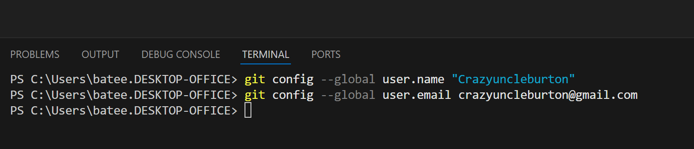
- Restart the VS Code app.
- Click Extensions (left hand toolbar) 
- Search “Platform IO” and install the Platform IO extension.
- Trust Platform IO if a popup box appears.
- Click Extensions (left hand toolbar): 
- Search “C/C++”
- Install the Microsoft C/C++ Extension.
- It’s Microsoft, so no trust needed.
- Restart VS Code if needed.

Opening the Project in VS Code

- Close all folders and projects in VS Code. File/Close Folder or File/Close Workspace will accomplish this.
- Go to the GitHub project here: https://github.com/CrazyUncleBurton/OtterPilot-v3.8.0-Plan-B
- Click the green Code button and press the copy icon next to the URL to copy the URL to the clipboard.
- Go to VS Code and click the Platform IO alien logo in the left toolbar and choose “Clone Git Project” from the Quick Access pane.
- In the window that opens at the top center of VS Code, press CTRL-V to paste the URL of the project and then press ENTER.
- A dialog opens asking where on the local machine to put the folder that contains the project. It’s asking what folder it should put the folder that contains the local copy of the project. The answer to this question is always “UserProfile\Documents\PlatformIO\Projects”. Just highlight the Projects folder, don’t browse into that folder.
- Click the Select as Repository Destination folder.
- The project will be downloaded to the local machine and open in VS Code.
- Platform IO will download the managed libraries and install a compiler for this CPU type. This may take some time, as it is updating the ESP32 Platform to Core 3.x at the same time.

Compiling and Uploading to the Microcontroller
- Connect a USB cable from the computer that VS Code is running on to the microcontroller.
- In VS Code, look at the bottom toolbar for the COM port icon 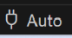 with hover text “set upload/monitor/test port” and click it.
- See if the device is present in the list that appears in the top center of VS Code. It should say “USBxx USB Serial Device (COMxx)…” with some randomly assigned COM port that isn’t in use by anything else. Don’t choose the USBxx USB Serial Device line – leave it set to Auto. Plugging the microcontroller into a different port can cause the COMxx number to change for the microcontroller.
- In VS Code, click the PlatformIO Upload icon in the bottom toolbar. The hover text will be PlatformIO: Upload.
- This takes the C source code and compiles it into machine code for the microcontroller you’ve chosen. Then VS Code will transfer that machine code to the microcontroller – this is called uploading.
- When it’s ready to upload, we see lines like “Connecting…” and “Writing…”. Wait for the line that says SUCCESS in green text before proceeding:
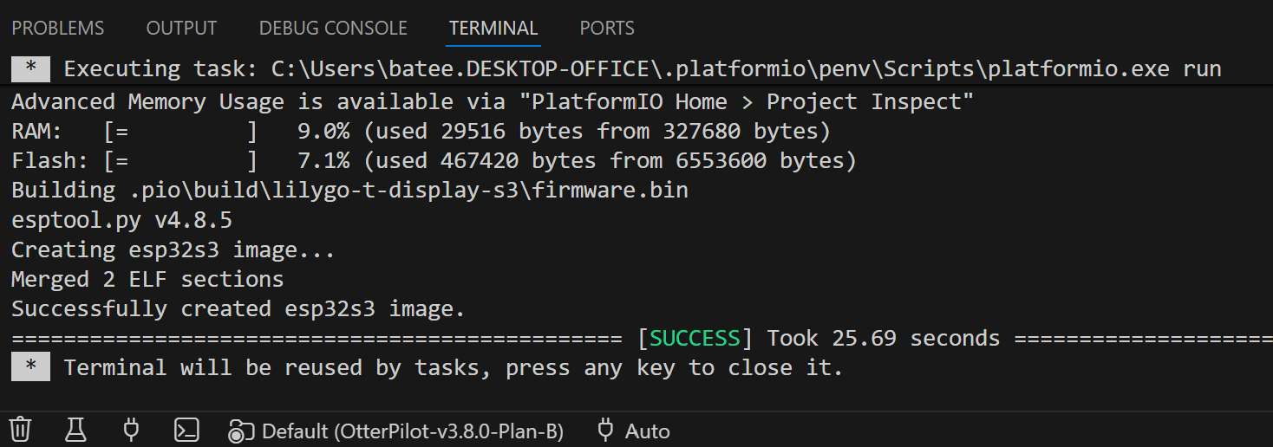

- When finished, the microcontroller will reboot and start running the program uploaded to it.

Branches
Branches are a way of creating different versions of code in a single project repository. Ideas are Production, Old, Development, etc. Branching is different than Forking, which would be to copy the repository contents wholesale to project repository with a different name.

Creating a New Branch
By creating a new branch, we’re saying that we want to “branch” the project. This means take whatever code is open in the editor, which was a certain branch, and copy it to another branch with a new name. This leaves the current branch as-is, and causes all updates after the branch to go to the new branch name. To create a new branch, you need write permissions in the project:
- Look at the Current Branch icon 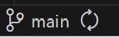 in the bottom left corner of VS Code. This shows that the current branch of the OtterPilot v3.8.0 Plan B project is main.
- The main branch contains the test program for newly produced OtterPilots. You may not commit anything to the MAIN branch, but you can commit to other existing branches or make up a new branch of your own and commit there.
- Click the Current Branch icon. This will show a list of existing branches in the top center of VS Code.
- If one of the branches shown is the one you want to change to, go ahead and select it. If it doesn’t exist, select “+Create a New Branch…” from that drop-down list in the top center of VS Code and enter the branch name and press Enter.
- Now if we look in the bottom left corner, we see the branch has changed: 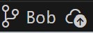
- There is a cloud icon with up arrow next to the name to indicate the new branch hasn’t been published to the repository yet.
- Click the cloud icon to the right of the branch name to publish the branch to the repository. The branch has been published to GitHub. We can verify that by going to the GitHub repository and looking at the list of branches.
- Now the branch name appears like this: 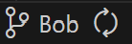
- The new branch has been published, and your local project is synched with that new branch.

Switching Branches
Maybe you want to put this branch on hold and go back to an older branch.
- Make sure you’ve saved your work. File/Save, and optionally commit that work to the GitHub repository.
- Click the current branch name in the bottom left corner of VS Code. A list of existing branches appears at the top center of the window.
- Select the one you want.
- Press the recycle icon next to the name of the branch you want to change to.
- The push/pull dialog appears, telling you it’s going to sync with the new branch:
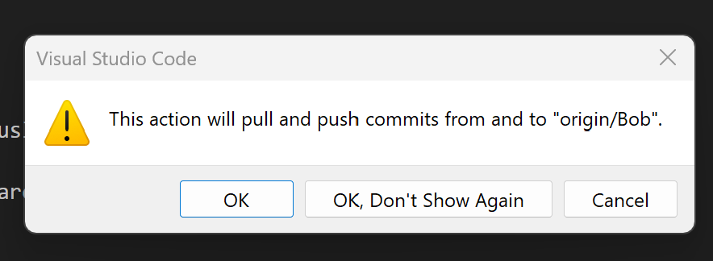

- Click OK.
- When the updates finish, the new branch name will appear in the bottom left corner.

Committing Updates to the Repository
Once we have made some update to the code on the local machine and want to store that code safely and share with others on the team, we can commit that code to the repository. This process will commit to the selected branch of the currently open project repository, as that’s the branch where the changes were done.
- Save your work by clicking File/Save. This saves each open and changed file in VS Code.
- Go to the Source Control icon on the left toolbar: 
- The blue dot with a 1 in it means that one file on the local machine project is different from the repository. We see a list of those file(s) in the left pane of VS Code:
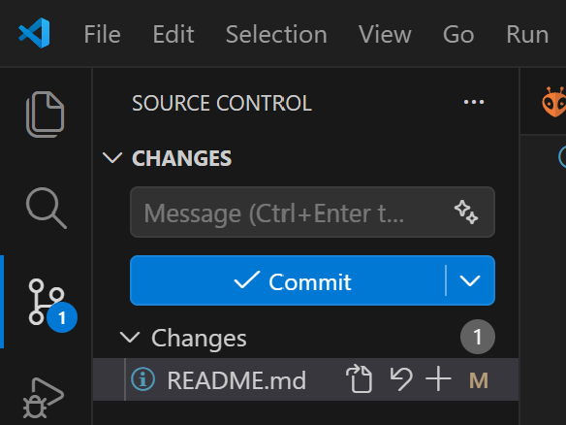
- Click Commit to commit those changes to the repository. A new file called COMMIT_EDITMSG opens in the middle pane of VS Code:
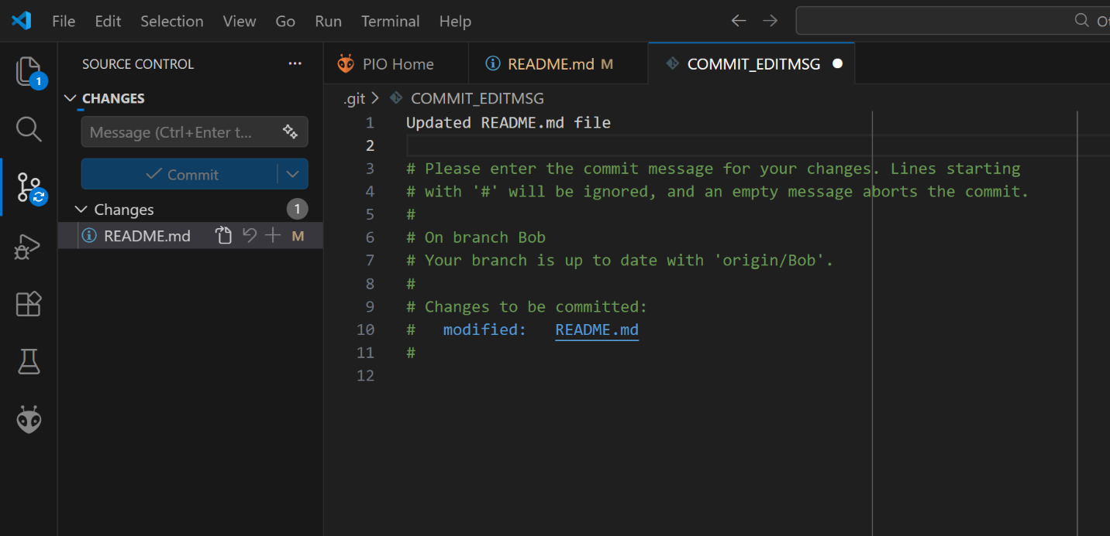
- In the top line or lines, type what you did to those files. “Updated README.md file” and any other helpful info, like “This isn’t working”, or “and Jeremiah is a goof,”.
- When you’re done updating the commit message, hover the pointer over the white dot next to its name and it will change to an X. Then click Save and the COMMITMSG file saves and closes.
- After we commit the changes we made, we need to sync them to the repository. The blue Commit button has changes to a “Sync Changes” button. Click it to upload the changes to the repository.
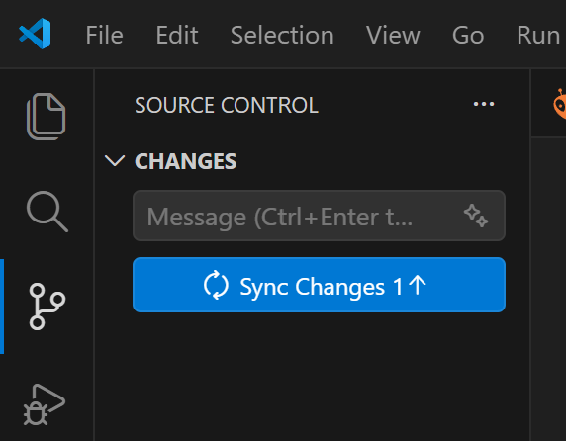

- The Push/Pull dialog comes up, saying that it intends to download any changes that have occurred on the repository to the machine, and to upload any changes to the repository, with the goal to make the two the same:


- Now the Source Control dialog shows no changes needed. The updates we made have been uploaded to the repository.
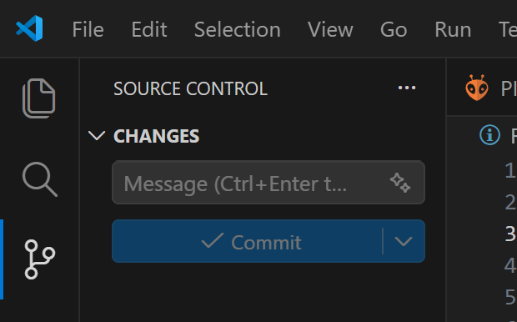

Scrapping Changes and Starting Over
If things aren’t working out, don’t commit it to the repository! To start over:
- Close VS Code folder or workspace you’ve been working on with File/Close Folder or File/Close Workspace.
- Go to <UserProfile\Documents\PlatformIO\Projects>.
- Rename the folder you have been working on. It will have the name of the repository you had open. Or if you know you don’t need it any more because you hate its face, just delete it
- Go to the section marked “Opening the OtterPilot Project in VS Code” and re-download the project to the local machine.

Things Still Aren’t Working
It happens. The changes we’re making with AI can mess something up in the VS Code installation, causing us to have to reinstall VS Code and its extensions.
- Close VS Code.
- Go to the Start Menu and click Settings and then Apps and then Installed Apps.
- Find Microsoft Visual Studio Code in the list.
- Click the three dots icon to the right of the app name and select Uninstall to remove it.
- Click Uninstall again to confirm.
- Once the uninstaller completes, go to <userProfile\Documents> folder
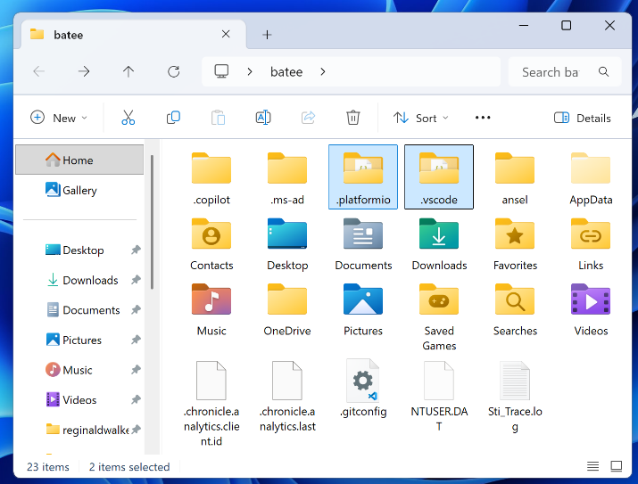

- Highlight the folders .platformio and .vscode. If they don’t appear, you may have to click “… and then Options and then View to see Folder Options :
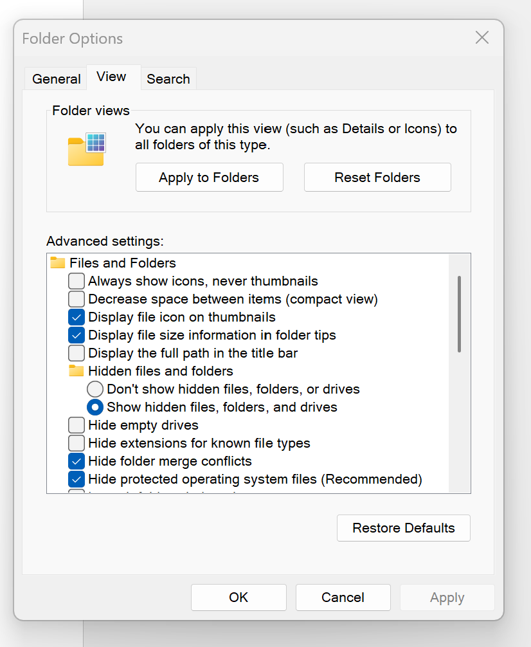
- Check “Hidden files, folders, or drives and then click OK.
- Delete the folders marked .platformio and .vscode.
- Browse into the UserID\App Data folder, and then the Roaming folder.
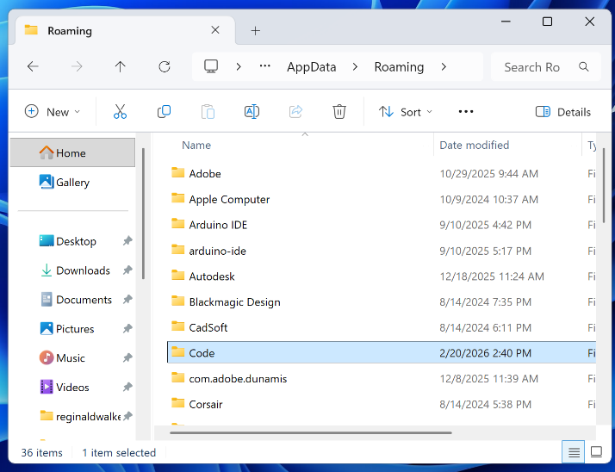

- Highlight the folder Code and delete it.
- Reboot Windows to clear any pending file and folder deletions.
- Go to the section marked “Setting Up a New Computer” and follow the instructions to reinstall and reconfigure VS Code.

Creating a New Project from Scratch
- Go to GitHub.com and login.
- Click Create the repository.
If you have a project that works with a specific microcontroller, it’s usually best to copy the files out

Reference
OtterPilot Repository: https://github.com/CrazyUncleBurton/OtterPilot-v3.8.0-Plan-B
Other CrazyUncleBurton Repositories: https://github.com/CrazyUncleBurton?tab=repositories

